BRIDGE TE AROHA: lovely place, lovely game ♠♥♦♣
Te Aroha News January 2024

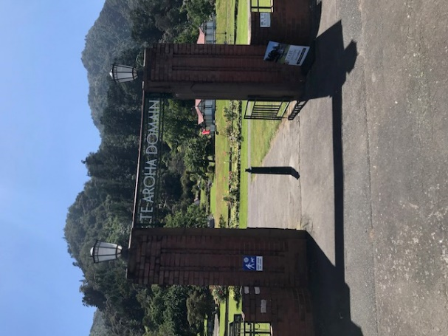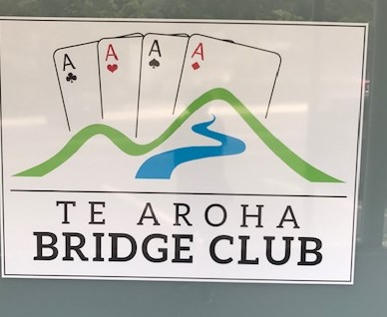
Welcome to another year of bridge in and around Te Aroha. Maybe you have already had a few sessions at the club? If not, then it would be lovely to see you back. If you would like a game but have not got a partner organised, then just text, email, phone..even call out (all work!) to Rochelle as she is still the Partnership Steward and will ensure you get a game.
Oh…and do remember that our official Tuesday start time is now 7.00pm…which means in your seat please by 6.45pm. Even those who stagger up from The Grand to play can manage it by that time. That gives us an earlier finish: well, an earlier time for when the port appears! We do appreciate that some of you might just prefer to get to bed a little earlier, too.
A Slight slip in the Tuesday night Programme
Eagle-eyed readers (not me!) may have noticed that Tuesday 17th September is missing from the book but Tuesday 24th September is there twice! Just to confirm that 17th September is the third night of the Saxon Teams while 24th September is week 1 of the “Three Week Individual”.

Whitebait, Ginger and Chokos!
What, you may, ask have the above in common and why are they mentioned here? Here’s a clue:
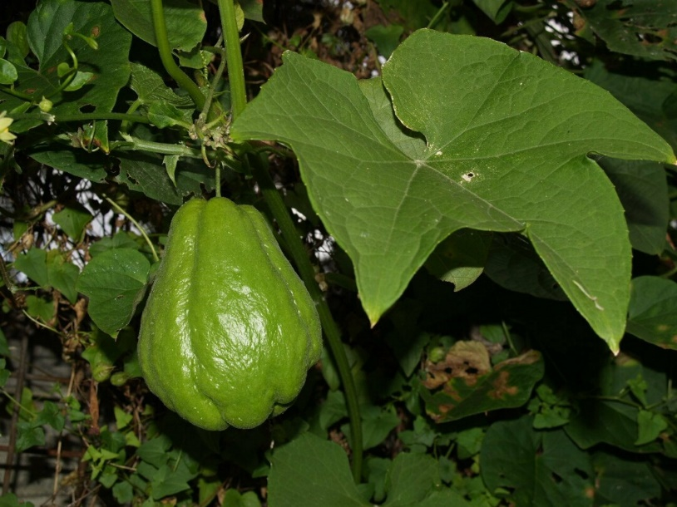
Well, you all know what whitebait and ginger looks like! Here’s another clue:
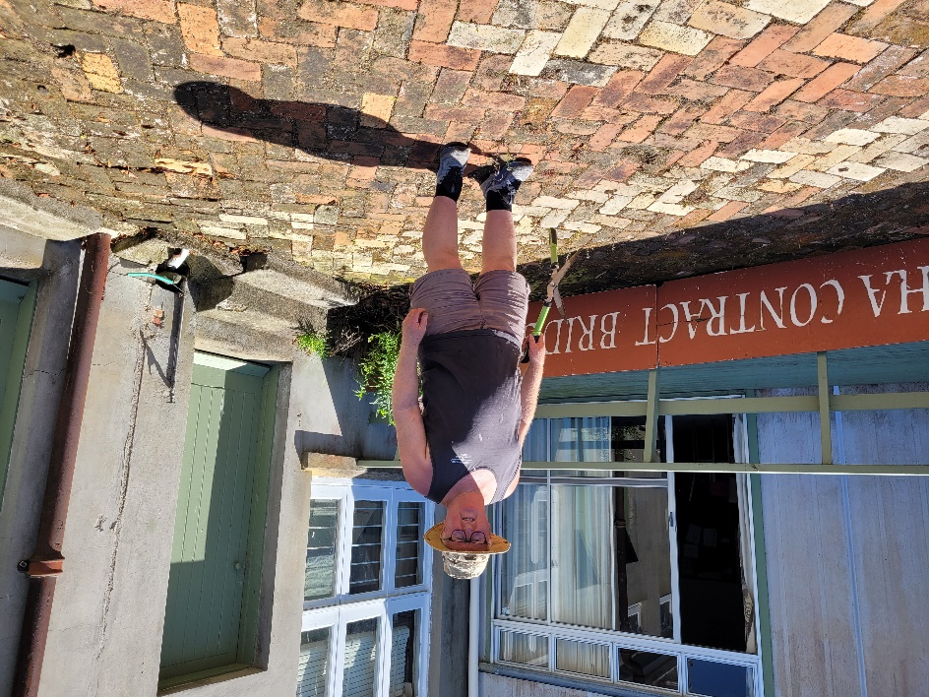
We have not taken many pictures so far at the rear of our bridge club. Here then is probably the first featuring Paul Decker looking ready for work. Paul is a Te Aroha Club member whom some of you may not have met. I am sure you will know his better half, Gaye. However, Paul is making himself rather useful as our groundsman. Gaye “volunteered” him for the role to get rid of the weeds. While Tyrel and Charlotte handle the lawns (many thanks), Paul does what is needed to keep the back of the club looking neat, tidy..and productive.
According to Gaye, Paul is one of the very few people in this world who like chokos. (me, I am one, too!) They have an extremely mild tasteless taste but they still have their fan club. Paul describes them as “tasteless marrows”. Hopefully, you will like them as Paul, with the committee’s say-so, intends to grow some in the club garden. So, perhaps some choko with your sausages and sausage rolls at the tea break in the months to come.
Now, Paul also has an interesting job. He is general manager of a company called Manaki Whitebait. The company is owned by a Central North Island Trust, Ngati Tahu-Ngati Whaoa Runanga Trust, and commercially farms whitebait. Originally based in Warkworth (where Paul and Gaye lived until moving to Te Aroha a couple of years ago), it has moved some of its operations to Bluff to take advantage of more space, cooler temperatures and cheaper seawater. Whitebait normally travel from rivers to the oceans and back again a season later. Here, their travel is limited to around large circular tanks.
Most of the female kokopu are in Warkworth with the staff taking the eggs from the sedated mothers by hand and then air-freighting them to Bluff where they are mixed with the male’s milt. Paul describes the operation as “like baking a cake”. The Bluff operation is part of a large aquaculture operation in the old freezing works at Bluff. This new operation including the whitebait breeding is featured in the January/February 2024 New Zealand Geographic Magazine. If you would like to read more about the operation, I am sure Gaye or Paul will lend you a copy.
Paul comes from a Queensland dairy farming background. When he was young, he started breeding fish in farm dams. He also worked in his youth in a ginger- growing area. This has led on to another role that Paul has of advising at a ginger and turmeric- growing plantation in Fiji.
When young, he played “500” with his parents and later was “encouraged” by Gaye and others to take up bridge in Warkworth. There, he helped the local bridge club with land issues with the local council. It seems Gaye ensures he is gainfully employed where-ever they play bridge.
After 20+ years of being involved with whitebait, Paul is likely to retire this year which will leave him with more time for playing bridge….and growing chokos!
Summertime
When the weather gets warmer (certainly) and drier (maybe). There have still been plenty of opportunities to play bridge in Te Aroha. I can report a better picture than 12 months ago when the courts at Stanley Street (the Auckland one) were totally water-logged.
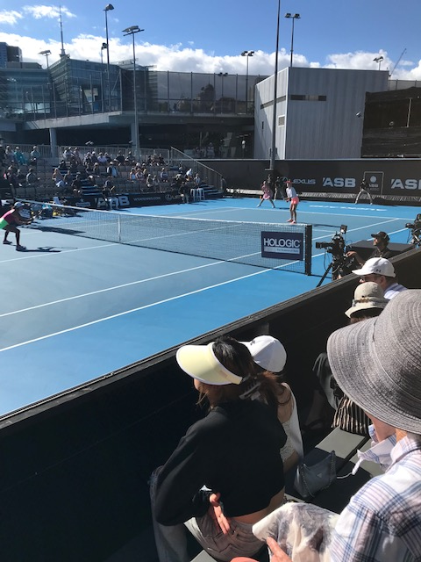
All good for tennis this time round. Only sun-shades and not one umbrella in sight.
Tim on Tour
Last time, we showed you Tim and his family getting into pizzas at his son, Reese’s, favourite restaurant in Chicago. They continued on for a tour of Florida including to Disney World where we caught up with them. Then, their version of “Pirates of the Caribbean” as with a few others the Rigters took over a cruise ship in that water-way for two weeks of well, pure bliss.
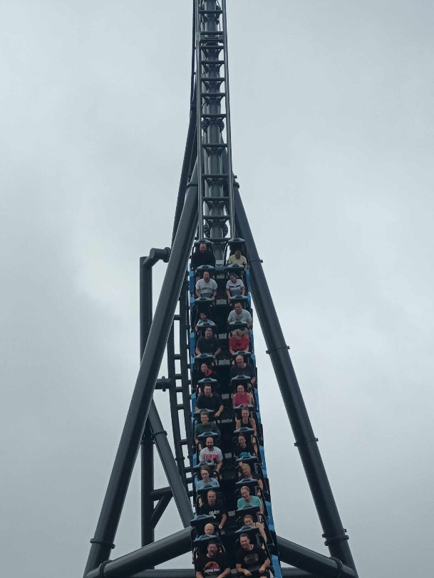
I believe Tim is in this picture. Can you He also claims to be in this one.
spot where? Roller-coaster here we come!

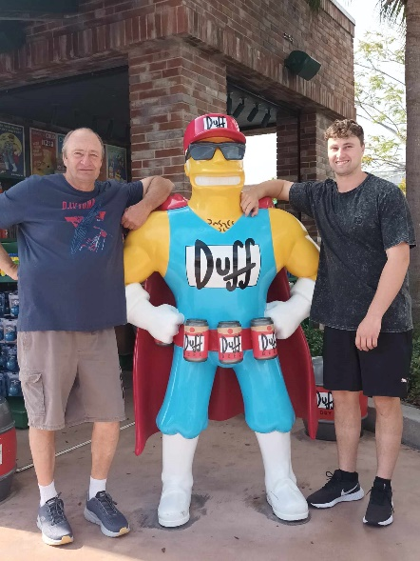 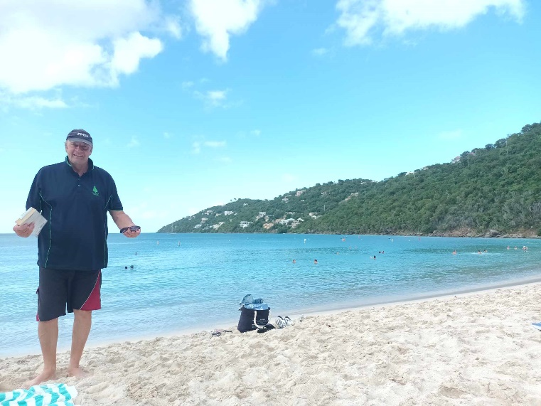
Tim, Reese and the man on the cruise and no doubt with a bridge book in
in the middle his hand.
All good things must come to an end and Tim is of course back to bridge in Te Aroha and with Rochelle, taking an early lead in the Pro Tag Swiss Pairs. That break..and a bit of bowls must have done him good.

“Tailgate”
Truth is just so much better than fiction
A “double” crime with finesse
No bridge hand in this story: just a “sleight of hand” or plain cheek!
Would you think the following story is true or made up? Ask Peter Daffurn and his “landlord” (Peter TJ’s word) and friend (Peter Daffurn’s word), Peter Tait-Jamieson. In case any other club member may feel implicated, his name appears for the one and only time in full in print.
‘Tis a sunny Saturday morning in Te Aroha in early January and Joy collected “the other Peter” other from Peter TJ to go to Thames for a nice day’s bridge. Peter and Joy enjoyed their day but dark clouds were looming ..and not in the sky!
Meanwhile, his friend and landlord started the day in different fashion. Needing to go to his old family farm just out of Te Aroha, Peter TJ borrowed the other Peter’s” work vehicle as it had a towbar.
On leaving town, he picked up a youngish hitchhiker who according to Peter TJ seemed a very pleasant man, even if he had a rough-looking scar on his neck. Don’t all nice guys have such marking!
They stopped off at the farm to pick up his trailer and put some household items into it. He was heading to Matamata but the hitchhiker was going to Morrinsville. So, they headed off on the Kereone Road to Morrinsville. Part way along, Peter stopped to adjust the items on the trailer and, leaving the keys in the ignition, climbed into the trailer.
It seems that his passenger seized the moment. He climbed into the driver’s seat and drove off with the trailer and Peter “in tow”. Peter was thrown out of the back off the trailer by the sheer shock of it all, landing bruised but winded on the road.
Meanwhile, the hitchhiker was having his own problems as the tailgate on the trailer was down, hampering his escape. So, our “crim” stopped and adjusted the trailer before heading off being chased down the road by a frantic Peter wearing just one jandal and who, in his own words, “nearly caught the bastard up”. (a few adjectives were left out of this sentence). The pursuit failed to attract other motorists’ attention. It must be a common occurrence to be thrown out of a trailer in Kereone Road and then engage in chasing one’s vehicle on foot!
Peter had lost his mate’s company vehicle, his own trailer and items on it, his wallet which was in the vehicle, and a fair amount of pride!
Fast forward a week and the police, who had a very good description of “the bastard” as he had sat next to Peter prior to the theft, arrested two people in Hamilton in connection with the incident….and were soon to arrest two more.
Rumour has it that Peter Daffurn’s boss was none too pleased about the loss of his company vehicle and would no doubt have been pleased with its return albeit a bit battered and bruised.
Safe and Sound (well nearly) back in
its home town!
Peter TJ need not have his hand up. The car has now
been returned to its rightful owners in Te Aroha.

No wallet unfortunately or bridge coffee card (no doubt, Victor will watch out in case it reappears at the club!)though there was no other monetary loss there…but the trailer has not been found.
Is there a moral to this story? Only perhaps take your keys and your wallet with you when you stop to get in your trailer….and ruefully, maybe take your own car to bridge!
The Monthly Tip
About bridge, of course!
of Solomon!
The suggestion has been made to me that I could include one in each issue of this newsletter. I will try.
This month, I will highlight a common error in defence. That is “third player playing high” when it cannot benefit their side to do so.
“What” I can hear you say. “We were taught that third player does play high!”
Indeed that is true. Yet, like most bridge rules, there are glaring exceptions when by doing so, you just help declarer!
Take this example. The opponents bid simply to 4H and you sitting East notice your partner leads D9.
This is what you see in dummy and your own hand:

♠ | J 6 4
♥ | 10 8 7 5
♦ | A J 10 8 5
♣ | 5

 | N  W E  S | ♠ A 7 3  ♥ 9 6  ♦ Q 6 4 3 2  ♣ J 8 7

West | North | East | South
 | Dummy | You
 |  |  | 1 ♥
Pass | 2 ♥ | Pass | 4 ♥
All pass

Declarer calls for DJ from dummy. Now is the time to be careful. Ask yourself about your partner’s lead. The basic guideline says “3rd player plays high” but it should continue “only when it will or could benefit your side in doing so”.
Looking at dummy’s diamonds, you know the lead is either a singleton or from 97 doubleton. You know South has DK. They want you to play your queen to set up diamond tricks in dummy. Be a spoiler. Play low!
The above is quite an extreme example but there are many times when you should remember the whole guideline and do not help the declarer. If you can play low in perfect tempo, even better. There are times when you as third player even takes a finesse by not playing a high card….but I will show you that another time.
In the meantime, think before you play your high card.

Walking the Pairs Tightrope. ..or when -1400 is a good score!
I did recently. Would I survive…or fall off! It was pretty close. Here’s my hand…yours now:
North Deals  N-S Vul | N  W E  S | ♠ J 3  ♥ 7 5 4  ♦ 6 4  ♣ K Q 10 7 4 2

West | North | East | South
 | 1 ♠ | 3 ♣ | 3 ♥
5 ♣ | 6 ♥ | ?

You are East and make a Weak Jump Overcall in clubs (hopefully you are happy with that!). The auction gets high very quickly. Both opponents have hearts and North must have a good hand as they jumped to slam. What now? Have you finished bidding?

It looks like your partner was sacrificing with 5C. Our side is not vulnerable. North bid 6H to make, being vulnerable! We have no defence to 6H and it looks like our partner has very few hearts as we have three. So, how about bidding 7C? I did!

Then came a long hesitation from South. Would they bid 7H? Would it make? Had I pushed them into a making grand slam? Eventually, South passed and it was North’s turn to hesitate. Finally, after another few seconds, North doubled and I became declarer in 7C x. South led HA and these were the four hands:

North Deals  N-S Vul | ♠ A Q 8 7 6 2  ♥ K 10 6 2  ♦ A 10  ♣ 9
♠ K 10 9 4  ♥ Q  ♦ Q J 7  ♣ J 8 6 5 3 | N  W E  S | ♠ J 3  ♥ 7 5 4  ♦ 6 4  ♣ K Q 10 7 4 2
♠ | 5
♥ | A J 9 8 3
♦ | K 9 8 5 3 2
♣ | A

West | North | East | South
 | 1 ♠ | 3 ♣ | 3 ♥
5 ♣ | 6 ♥ | 7 ♣ | Pass
Pass | Dbl | All pass
I got my calculator out. I was going to lose a club, a heart, two diamonds and two spades….6 down..-1400. Now, it would seem that 7H did make, although my opponents and no-one else in the competition bid it. At least half the field bid to 6H and made 13 tricks. That score is +1460.
I lost my 6 tricks and was relieved and happy to escape for -1400. That was worth 14 matchpoints out of 24. I walked the tightrope….and survived!
Recently, Shirley Townsend asked me about whether being good at maths helped with bridge. On occasions like the above, it does help.
Committee News.
The club committee had a meeting in mid-January, or to be precise, half a meeting as they only got through part of the agenda…but here are a few outcomes from that meeting.
- Charlotte was appointed Education Officer for the coming year. She and Tyrel will be running the club beginners’ classes. More details after the next meeting but the start date is March 28th at 7pm (and note that they be on Wednesday evenings). Remember the best advertising tool is existing members, like you! So start mentioning to likely NEW LEARNERS you know about the classes.
- Yours truly was appointed Club Captain for a similar period. Actually, the period of both roles was not actually defined. Office holders like Chairman, Treasurer and Secretary are for one year. The above roles could be for life, even longer! The Club Captain looks after bridge aspects of the club though Jan (see below) will assume that role for Friday bridge. Thanks, Jan.
(There were three players whose name was those three letters at recent club sessions. So, thank you Jan Baker, for stepping forward.)

FUTURE CLUB EVENTS
Sunday March 10th The first heat of the Waikato Area Pairs is at our club. Let’s have a good turn-out from the locals for this event.

Saturday June 8th Spa Town Open Teams and 8B Multigrade Teams
While the 5A Open event may seem daunting, the Multigrade should be fine for all other members. Neat atmosphere and a nice day at a time of year when it is nice to be in-doors.
Well, that’s all for January. Hope to see you all contesting the Pro Tag Pairs at the club. 10 tables on week one. That’s great. Thanks, Tyrel and Charlotte…oh for those yummy chocolate eclairs, too.
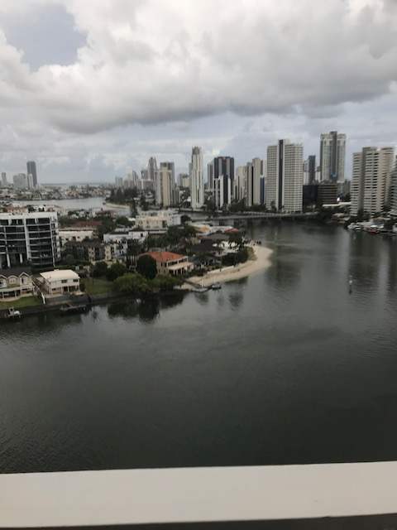
Back in February after the gang have headed off to The Gold Coast Congress. See you then.
Richard

